Course Outcomes

CO-1 | Interpret the functional architecture of operating systems. (Understanding)  - Classify and study various OS implementation techniques.  - Understand how to implement system calls.  - Relate to fundamentals for file system implementation.  - Understand the basics of paging and segmentation and study advanced combination schemes based on them.  - Learn about various I/O devices and the I/O function.  - Appreciate process management functions like user/kernel level threads, multithreading, deadlock and process synchronization.  - List down the issues and ways to enforce system protection and security.
CO-2 | Identify, compare and assess issues related to process management, file systems and memory management. (Applying, Analyzing, Evaluating)  - Estimate the performance of various memory management techniques.  - Compare page replacement techniques.  - Analyze deadlock situations and suggest remedies.  - Evaluate advanced implementations like LFS and optimization for file system performance.
CO-3 | Design and analyze solutions in the area of operating systems. (Analyzing, Creating)  - Solve synchronization problems using synchronization tools like semaphores, monitors etc.  - Ability to add system calls to an OS.  - Ability to write multithreaded code.

Assessment of Attainment of Course Outcomes
Assessment Type | Course Outcome
 | CO-1 | CO-2 | CO-3
Final Exam | 40% | 30% | 30%
Assignments | 40% | 30% | 30%
Mid Sem Exams | 40% | 30% | 30%

Question Paper to CO mapping
Sessional 1 |  |  |  | Sessional 2 |  |  |  | End Semester
Q.No. | CO-1 | CO-2 | CO-3 | Q.No. | CO-1 | CO-2 | CO-3 | Q.No. | CO-1 | CO-2 | CO-3
1 | √ |  |  | 1 | √ |  |  | 1 | √ | √ | √
2 |  | √ |  | 2 |  | √ | √ | 2 | √
3 | √ |  |  | 3 | √ |  |  | 3 |  | √
 |  |  |  |  |  |  |  | 4 |  | √ | √

UAD | MMD | ASM
Moderation Committee

End Semester Examination Winter 2018

Branch: 5th Sem, B.Tech. CSE Course: Operating Systems (CSL309)
Duration: 3 hours Max. Marks: 50

Note: Attempt subparts of a question together. State clearly any assumptions used for answering.

 |  | Answer the following with respect to Memory Management. | 15
In a consulting work, you are asked to give a performance assessment of four prototype systems. In all of the systems, it takes the CPU 100 ns to access memory and the access time of a TLB is considered negligible. The page table is stored in memory. Draw the address translation mechanism too for each case.
- For system with a single-level page table and no TLB, how long does it take to access a paged memory reference?
- For system with a two-level page table and no TLB, how long does it take to access a paged memory reference?
- For system with a single-level page table and a TLB with a 70% hit rate, how long does it take on average to access a paged memory reference?
- For system with a two-level page table and a TLB with a 80% hit rate, how long does it take to access a paged memory reference?
Why and where is Buddy Allocator used? Give the pseudocode for allocation and release.
Consider a memory block size of 1050 KB to be allocated using Buddy allocator where the smallest block size is 64 KB and the upper limit for the order is 4. Show the state of memory allocation after each of the following memory requests in order: Request A (100K); Request B(240K); Request C(64K); Request D(256K); Release B; Release A; Request E(75K); Release C; Release E; Release D.
Consider the following page reference string: 1, 2, 3, 4, 2, 1, 5, 6, 2, 1, 2, 3, 7, 6, 3, 2, 1, 2, 3, 6.
Assume each case separately and for each case the frames as initially empty. Calculate the number of page faults that would occur for each of the page replacement algorithms (LRU, FIFO, OPTimal) assuming one, two, three, four, five, six and seven frames. Show your calculations clearly and finally populate the total page faults in the table given below.
No. of frames | LRU | FIFO | OPT
1
2
3
4
5
6
7

 |  | Answer the following with respect to File Systems and Input Output. | 10
 |  | What is a directory? What are the two most popular ways to implement a directory?
Suppose you have a Terabyte partition on a disk, subdivided into blocks of 8 Kbytes.
- How many blocks are on the partition?
- Each i-node is 128 bytes. You want to have enough i-nodes to store 2²⁰ files. How many i-node blocks do you need to store all the i-nodes?
What are all the checks which a file system consistency checker might be doing?
An implementation of the FSCK program traverses the file system tree and builds two lists of the disk blocks. One list contains the sectors that are shown to be in use, while the other reads the free disk-block information on disk. If the two lists for 4 blocks were as shown: Identify what are the problems, if any, and what should fsck do for each block.
In-use | 0 | 1 | 0 | 1
Free | 0 | 0 | 1 | 1

 |  | Answer the following with respect to Deadlocks. | 10
A system has five processes and four allocatable resource types and is using the Banker’s algorithm. The current allocations and maximum needs are as given below. The resource types are available in the following amounts: R = (3, 2, 1, 1) at this snapshot.
Maximum Needs |  |  |  |  |  |  |  | Current Allocations
 |  | A | B | C | D |  |  |  | A | B | C | D
P₀ | 6 |  | 0 | 1 | 2 |  |  |  | 4 | 0 | 0 | 1
P₁ | 1 |  | 7 | 5 | 0 |  |  |  | 1 | 1 | 0 | 0
P₂ | 2 |  | 3 | 5 | 6 |  |  |  | 1 | 2 | 5 | 4
P₃ | 1 |  | 6 | 5 | 3 |  |  |  | 0 | 6 | 3 | 3
P₄ | 1 |  | 6 | 5 | 6 |  |  |  | 0 | 2 | 1 | 2
- Write the pseudo-code for Banker’s algorithm, with a provision to record the safe sequence as well.
- How many total resources of type A, B, C, and D are there in the system?
- What are the contents of the need matrix? Is the system currently in a safe state? Why?
- If P₄ requests for (1, 2, 0, 0), can the request be immediately granted? Why or why not? If yes, then show an execution order.
 |  | What are the methods for deadlock prevention? Describe in detail the methods for violating the circular wait condition.
 |  | Answer the following with respect to Process Management. | 15
 |  | 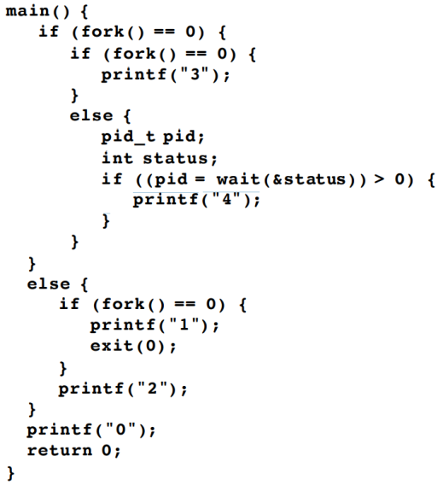 Consider the C program alongside. Assume that none of the system calls fork or wait fail. Also assume that all processes run to normal completion. Which of the outputs listed below are valid outputs of the program and why. For each valid output show the interleaving of instructions that might have taken place. - 2030401 - 1234000 - 2300140 - 2034012 - 3200410
Given are a set of jobs with a particular arrival time, a duration (the amount of CPU time it will need, in time units), and a priority. Given a choice between running two jobs, the one with the higher priority wins. If they have the same priority, the one with the earlier arrival time wins. There are no two jobs with the same arrival time. All jobs are purely CPU bound. A CPU should never sit idle if there are jobs to run. That is, the scheduler always runs when a job completes. The turnaround time of a job is the time between arrival and the time the job finishes. The response time of a job is the time between arrival and the time the job is first scheduled. For each case show your work by drawing a Gantt chart as well.
- Assuming there is no preemption, fill in the following table (higher number is higher priority):
Job | Arrival | Duration | Priority | Turnaround Time | Response Time
A | 0 | 25 | 0
B | 15 | 25 | 1
C | 20 | 5 | 3
D | 40 | 5 | 2

- Suppose the arrival of a job at time T causes the scheduler to run and select a job to run at time T, being able to preempt the job that was running. Fill in the above table separately for this case.
- Assume that the scheduler runs every five time units (i.e., at time 0, 5, 10, etc.) and also whenever a job
finishes. This time the priority of a job is not pre-assigned and static, but determined by how long it has been on the run queue (aka ready queue) since the last time it ran (or since it arrived in case the job hasn’t run yet). A job that has been waiting longer gets priority. In case of a tie, the job that arrived earlier runs. Fill in the following table:
Job | Arrival | Duration | Turnaround Time | Response Time
A | 0 | 25
B | 15 | 25
C | 20 | 5
D | 40 | 5

Consider the following synchronization problem: There are three processes: P, Q, and R. All three are executing a loop from 1 to N. You wish to enforce the condition that no process may enter the (I+1)^{th} iteration until the other two processes have completed the Ith iteration. Show how this condition can be enforced using semaphores.
Pseudocode for a process is given as
while(1)
{
for I := 1 to N
{//Body of loop}
}
 |  | What are the three typical uses of semaphores?

Solutions

1a | 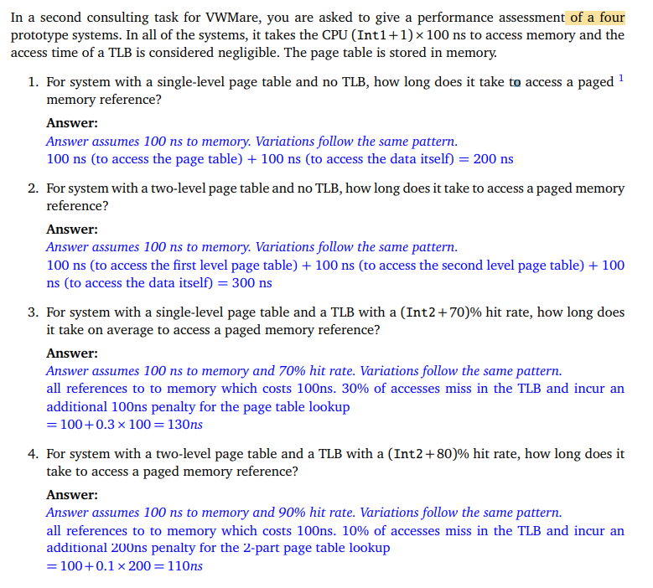
b | 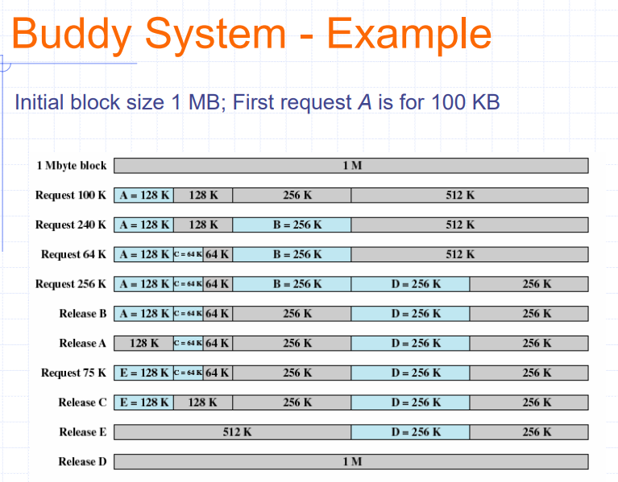
c | 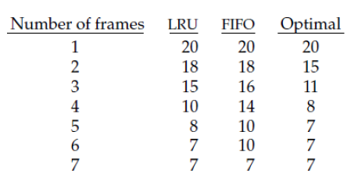
2a | 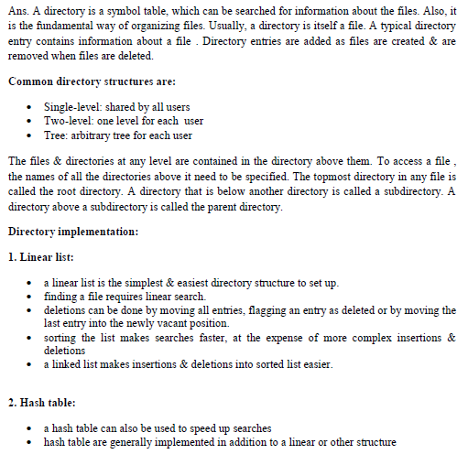
b | 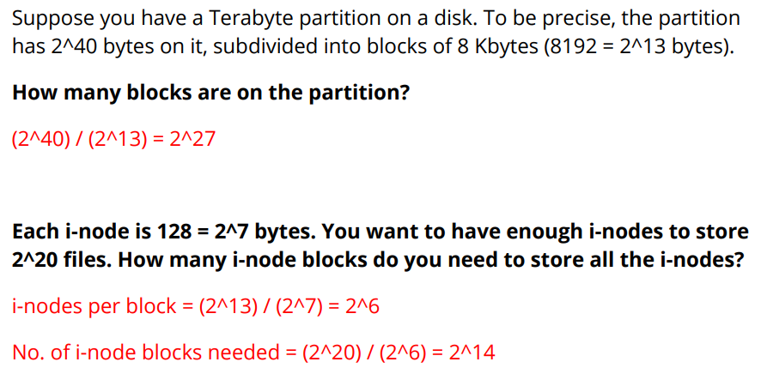
c | 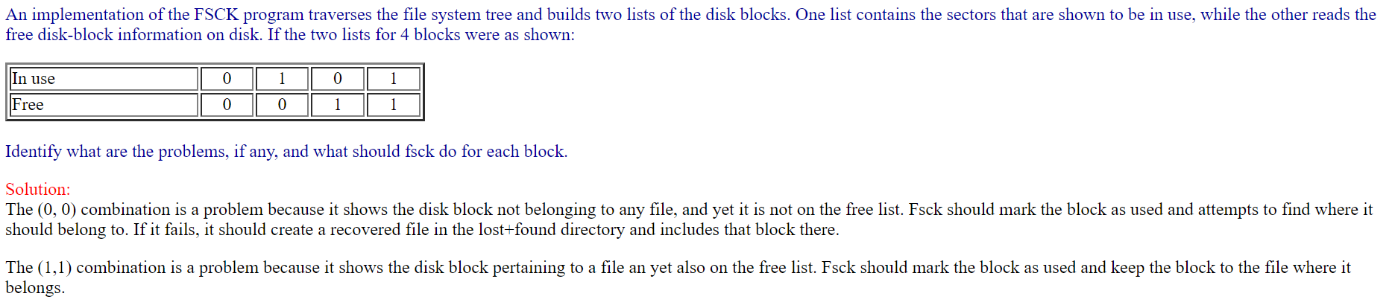
3a | 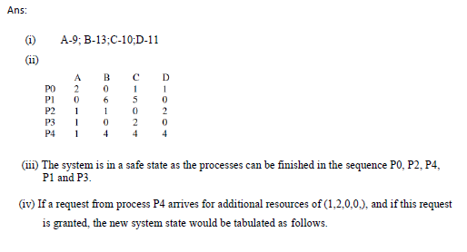  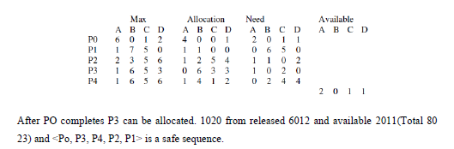
b | 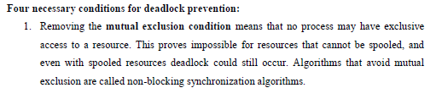  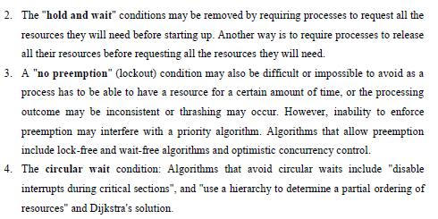
4a | 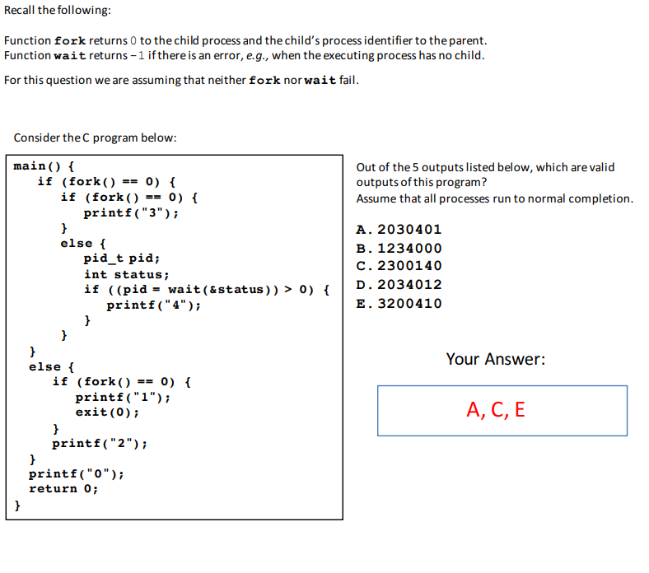
b | 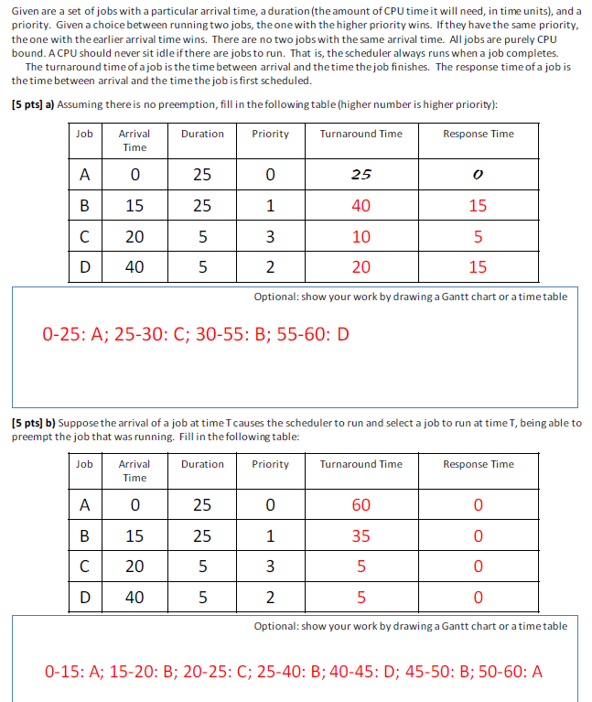  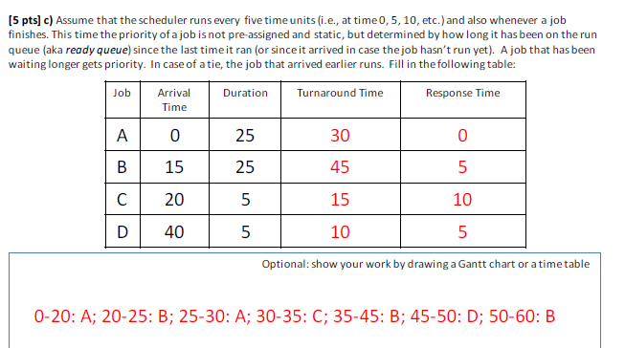
c | 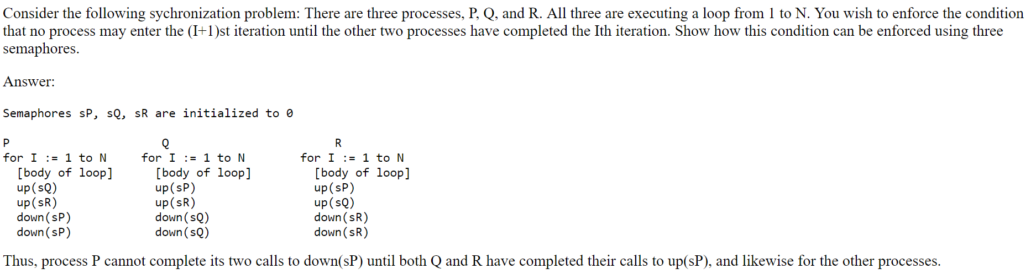
d | 